(Basic information, left justified, 11 or 12 pt. type)

<Name>

<Course Report is for>

<Date submitted>

(Page numbers have been added to this template – this is a professional touch that is highly recommended)

**Centered, Bold – 14 pt.: Title of Report or Assignment**

# Objective <Heading 1, Black lettering>

<Normal, 11 or 12 pt.> Describe the objective of the assignment or report. This includes the purpose of the report and a brief description of the results to be reported. For example: This template provides guidance on formatting and organizing a laboratory or design report to make the report more readable and more informative, and to abide more closely with the standard reporting formats of industry.

# Introduction <Heading 1, Black lettering> (for design reports)

Describe in a paragraph or two what you are doing and why you are doing it, to give the reader enough background to understand what they are about to read. For example:

An important aspect of an engineer’s job consists of effectively communicating the results of experiments, simulations, and/or theoretical investigations to their peers, management, and potential or current business partners and collaborators. Engineer’s skilled in effective communication are more valued by their company or organization in general. This report describes a general method for organizing and presenting information that will enhance the user’s ability to effectively communicate their work.

# Equipment or Tools Used <Heading 1, Black lettering>

<Normal, 11 or 12 pt.> List of equipment (for lab work) and/or tools (such as simulation and analysis software) used to accomplish the work in the report.

* Equipment name and make (e.g. Agilent Oscilloscope, model #xxxxx)
* MATLAB with Simulink
* Circuit Lab

<Depending on the specific case and guidance from the instructor, the following sections may occur just once for the entire work being reported, or may be repeated for each section of a project, if the project or laboratory has a natural breakdown of pieces or a natural sequence of events/steps. If the section is repeated, the title should identify the piece of the project/lab the section to which the section refers.>

# Methodology <Heading 1, Black lettering>

In this section, first provide a description of what your goals or objectives were for the project or assignment. For a design project, you want to describe what performance requirements your design must meet to solve the problem or to achieve a successful design. For a lab report, you want to describe the purpose or objective of the lab – what are you trying to prove, understand or show using the data you collect during the lab activity.

Second, you want to provide information about what you did to come up with the design or meet the objectives of the lab activity.

For a design, you want to provide information such as

(a) where did you start?

(b) what assumptions did you make, if any?

(c) if you picked values instead of solving for them, tell the reader you did this, why you did this, and give a reason for the values you picked,

(d) show calculations or analysis you performed to come up with other values you had to design (amplifier gain, resistor values, filter parameters, digital logic, etc.), and

(e) provide a completed design that you plan to test in the experimental part.

For a lab report, you want to provide information such as

1. What measurements did you make, and why?
2. How did you construct the circuit/system/simulation?
3. What equipment/software was used?

Formatting for this section is as follows:

<Formatting is numbered list, without the indent>

1. Design requirements (design report) or Specific Objectives (lab report)
2. Create a design report that is well-organized, comprehensive, and easy to read
3. Determine the relationship between Thevenin voltage, Norton current, and Thevenin resistance
4. Description of Design Process (design report) or Sequence of Measurement/Analysis (lab report)

In this section, describe in a logical order how you proceeded in designing, analyzing, and/or measuring the project element or element(s). This section can consist of word descriptions, tables, equations and figures.

For word descriptions: Use paragraph form, proper syntax, proper punctuation, and complete sentences. Be as specific as possible – avoid frequent use of pronouns like it, its, their, and other pronouns that can cause confusion when reading. Define any acronyms that you use before using them in the rest of the report. For example, this report will discuss the signal-to-noise ratio (SNR) at several points, and the SNR will be important in communications class. All tables, equations, and figures must be referenced within the text of the word descriptions. Equations should be referred to by number, i.e. the formula for the time constant of the circuit is given in Equation (1) – also acceptable is saying the formula is given in (1). Figures should be referred to as Fig. # -- for example, Fig. 2 shows the basic circuit configuration used. Tables should be referred to by name – for example, the different design choices are shown in Table 2.

Both in the text and in tables, numbers must be correctly reported and formatted. All numbers should use either Engineering Notation unless Scientific Notation is the accepted standard. For example, you should not report a current as 0.0000562 A, instead you should report it as 56.2 μA, or 56.2·10-6 A for Engineering Notation, and 5.62·10-5 or 5.62E-5 for Scientific Notation. Similarly, use 20 kΩ or 20·103 Ω, not 20,000 Ω. When performing calculations, especially with numbers obtained from measurements with a limited number of significant digits, you must maintain the correct number of significant digits throughout your calculations and in your final answers. If the multimeter has only 2 significant digits for voltage, and your measurement of resistance is accurate to 2 or 3 significant digits, the current calculated from these numbers should not contain 5 significant digits. For example, the reading from a multimeter is 2.54 V, and the resistance is measured as 1.54 kΩ, the answer should be 1.65 mA, not 0.001649351 or 1.6493 mA, as this implies the original measurements contained 4 digit accuracy or more. All quantities and values used must contain units.

The use of special characters, superscripts, and subscripts is expected. You should not write microseconds as “us”, you must use “μs” for example. Use Ω for resistance (don’t write out “ohms,” and “kohms” is not acceptable) and lower case omega (ω) for radial frequency as other examples. Use x2 in text, not x^2. Use R2 in text, not R_2. For scientific notation, either use 4.25E+2 or, preferably 4.25·102.

Figures: <this is how you can separate sections within the overall methodology, you can also use subheadings from the “Styles” menu in MS Word> All Figures should be embedded within the report document – this can be a cut and paste, an “Insert 🡪 Picture” or something similar. The preference is to center align, with one Figure per “line”, using “In line with text” (in Microsoft (MS) Word, this is the default case). Every figure must have a caption underneath, centered, and in 10 pt. font, containing the figure number and a short but informative description of the figure contents. The caption may either be part of the text in the report, or it may be a Text Box with the same properties. Captions must be on the same page as the figure. All words and numbers in the Figure must be legible (i.e. a professor with older eyes can read them without the help of a magnifying glass!).

If you know how to place figures side by side, you may do so when the figures are related (a circuit and the results of its simulation) as long as the captions are centered under the corresponding figures.

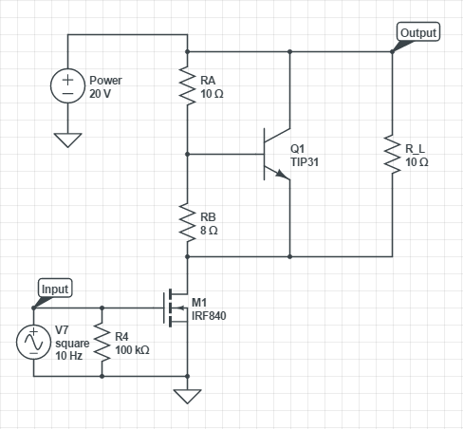

Figure 2: Final design of the shunt driver circuit

*Graphs and Plots as Figures:* A special case of figures is the graph or plot, typically imported from Excel, MATLAB, PSpice, CircuitLab or some similar program. There are some general rules for including these types of figures in a report document.

1. All graph/plot axes must be include a label that describes what the axes represents and the units – i.e. time (ms), V2 (V), and Iout(t) (mA). For oscilloscope traces, you will need to either add the labels with text boxes, or identify the axes labels in the caption.
2. If plotting multiple signals or lines on the same graph, there must either be a legend, or you must add labels that identify which signal is which.
3. Each axis must have either numbered axes or (in the case of oscilloscope screen captures) information on the scale (V/div, ms/div) used in the graph.
4. If using cursors for measurements, the cursor lines must be legible (or otherwise identified) and the cursor output values must be large enough to read. If you can’t make the cursor measurements large enough, you must report the values as part of the text that refers to the figure.
5. All numbers and lines on the figure must be readable by someone with an older set of eyes. In Excel and MATLAB, you have tools to control the font size of all numbers and labels. From PSpice and CircuitLab, the options are limited, so you should make sure to increase the size of your figure sufficiently to make the numbers readable.
6. Special note related to item 5: When plotting from any program, make sure that the background is white, on both the graph and the axes areas. The only exception to this is when you are able to print in color, as the color enhances readability. Examples of good and bad are shown below.

Good:

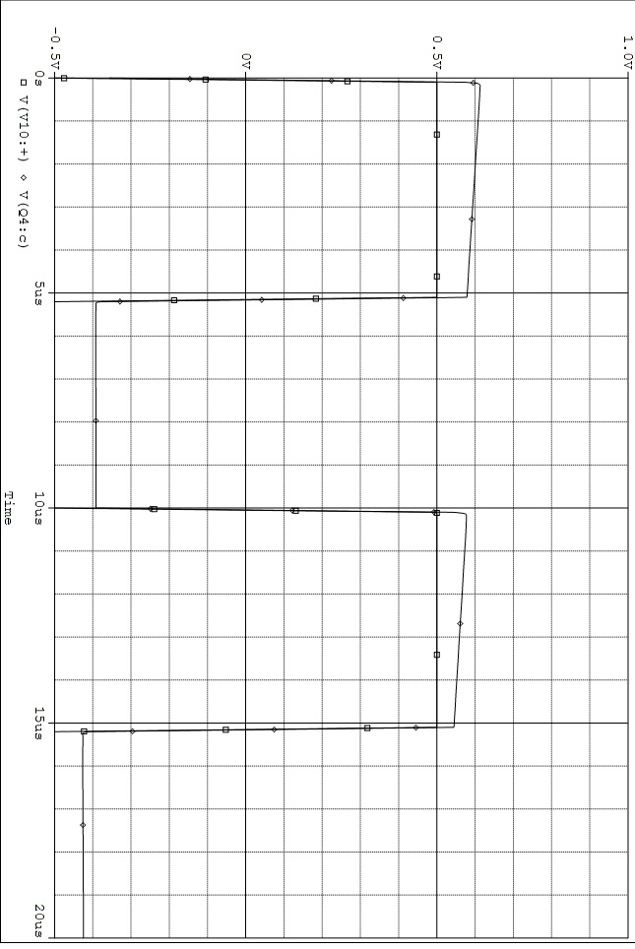

Figure 9: A good screen/data capture from PSpice, showing the output voltage vs. time.



Input voltage

Output voltage

Figure 10: Oscilloscope capture showing the input voltage (channel 1/yellow) and output voltage (channel 2/green) vs. time. Note that scales are along the top of the capture – this is okay. Text boxes and arrows have been added in Word for labeling, in case the report is printed or viewed in black and white.

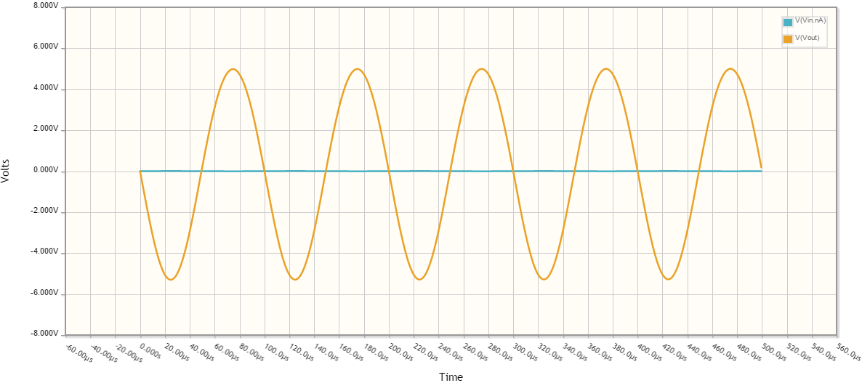

Figure 11: Best example of output from CircuitLab. Better if legend was expanded for readability. Text boxes, like those in Fig. 10, can also be added for clarity.

Bad:

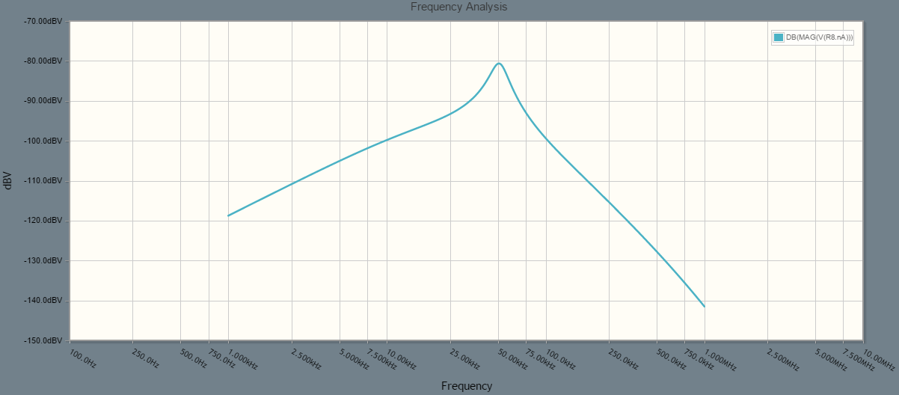

Figure 12: The dark background and small legend make this difficult to read, especially in black and white.

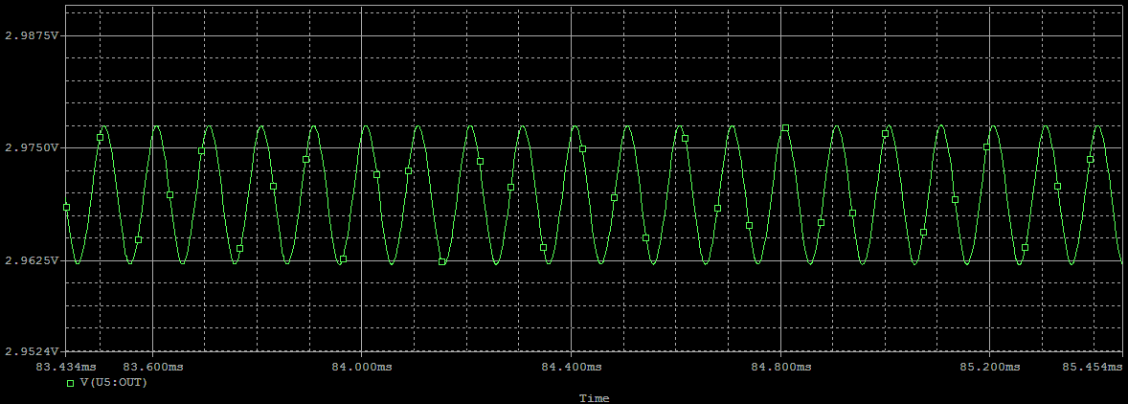

Figure 13: PSpice plot of the output voltage from the op-amp vs. time. Only okay if printed in color. Bad if printed in black and white.

*Pictures as Figures:* For some situations, it may be acceptable to use a picture taken with a camera or phone as a figure in a report. Please check with your instructor for specifics on what is acceptable. In general, the rule is that the picture must add information to the report – a picture of the actual completed circuit, or that shows the relative sizes or dimensions of systems or designs. Do not add pictures simply to fill space or add interesting visuals, and poor quality pictures (glare blocking information, not well focused, etc.) should never be included.

Equations: Use the equation editor in Word (or similar program) to produce equations more complicated than V = I*R. Make sure that the equation is centered, and that key equations (ones that you will refer to in the text, or that lead to other equations) are labeled with a number to the right of the equation. The preference is for the equation number to be right justified (i.e. sitting on the right margin), though this requirement may or may not be enforced by different instructors.

Best:

$A_{v}= \frac{{-g}_{m}R_{D}}{1+ g_{m}R_{S}}$ (1)

Acceptable

$A_{v}= \frac{{-g}_{m}R_{D}}{1+ g_{m}R_{S}}$ (1)

Av = -gmRD / (1 + gmRS) (1)

Bad:

1. Av = -gmRD / (1 + gmRS)

Av = -gmRD / (1 + gmRS) (1)

Tables: Tables should have a label for each column, and each label should include the quantity *and* the units of the quantity (Vout (V), I(t) (μA), t(ns), for example). Preference is for all table entries to be centered in their cells, and for all entries in the table to be readable. Do not use 7 pt font just to squeeze more information into a table – make multiple tables if need be. Tables should be centered, with the Table label *before* the table.

Table 1: An example of a good table

|  |  |
| --- | --- |
| Vin (V) | Vout (V) |
| 1.0 | 2.0 |
| 2.0 | 4.0 |
| 3.0 | 6.0 |
| 4.0 | 8.0 |

# Results <Heading 1, Black lettering>

In this section, present the results of the design activities or laboratory measurements. Some points to follow in this section:

1. Use headings or other indicators to link results to specific parts of the discussion in the Methodology section, so that the reader knows which results go with which parts of the design/laboratory procedure.
2. Always describe how measurements were made (did you use an Ammeter in series to measure a current, or a volt meter across a resistor, for example). Remember, more detail is better than too little, and the goal of the report is that the reader could, theoretically, repeat your analysis or experiment based on the information you provide. Also, when writing, do not assume your audience has a copy of the lab manual or handout to refer to.
3. Always report actual measured values of components, if possible – resistors, capacitors, power supply outputs, for example – never trust the rated values!
4. Follow the rules for Figures, Equations, and Tables in the previous section.
5. The results section should not include all of the raw data for an experiment, unless the instructor requires you to do so. Instead, include samples of data sets in the results section and put the raw data in an Appendix after the Conclusion section of the report.
6. The Results section is not the place to present your MATLAB or other programming code used in the analysis, unless the code is one of the results required of the project or laboratory. Instead, include the code in the Appendix.
7. When making comparisons between graphs or numerical quantities, use numbers or analytical methods rather than words. For example, if your theoretical value was 5 mA, and your measured value was 4.6 mA, your comparison should be stated in % error, % difference, or in difference in the values. Your comparison should not be “it was kind of close” or “it looked good.” These are not engineering or scientific in nature.
8. Provide enough information that the reader can link together the pieces of your analysis and that you tell a clear story.
9. When answering questions – retype or repeat the question from the handout or manual, so the reader knows what question you are answering. Do not just put down the answer. **Always** provide a full sentence answer, not just a “no” or a “yes”. The best answer provides a reason why you answered the question the way that you did.

Examples:

Good: Does the regulator perform well as the input voltage changes? Yes, it performs well because the output voltage changes by only 5 mV when the input changes by 10 V.

Bad:

Does the regulator perform well as the input voltage changes? Yes.

Yes. (next to which Dr. LoPresti writes – yes, what? – before deducting points)

Depending on the requirements of the assignment, conclusions and answers to specific questions may be included in the results section, or in the Conclusions section that follows.

# Conclusions <Heading 1, Black lettering>

This section should contain, at minimum, one paragraph that contains a summary of the major findings of the design and/or laboratory work presented in the body of the report. Depending on the assignment, you may need to answer questions in this part or to provide some further analysis of the results in this section.

# Appendix <Heading 1, Black lettering>

In separate sections, include programming code, raw data, and additional pictures related to the report that are not included in the results and Methodology sections.

**Other Notes:**

1. Please check with your instructor about whether or not electronic submission is allowed. Many instructors prefer the student to produce a hard copy for grading.
2. If submitting through Harvey, you must save the file in .pdf format, and the file size must be < 10 Mb in size, or the submission process will fail.
3. Once a report is submitted (and possibly returned after grading), it is the student’s responsibility to archive and keep reports for later use or reference, not the professor. Make sure you have some reliable place to store all reports until a class is completed.